Capstone Project
Egypt Food Security & Economic Affordability Analysis (2020–2024)
Guidebook
CREATED BY:
CLS-CAI3-DAT2-S2 Team - 3
SUPERVISED BY:
Mahmoud Seraj
TECHNICAL PARTNER:
Computik Learning Solutions - CLS
Digital Egypt Pioneers Initiative

About the Authors: A Mosaic of Expertise
We are a team of five brought together by the Digital Egypt Pioneers Initiative (DEPI), each contributing unique professional and academic backgrounds.

👤 Omar Sherif (omarsheshtawy2121@gmail.com)
👤 Abdolrahman Ashraf (abdolrahmaneata@gmail.com)
👤 Ahmed Mohamed (ahmedkalabala1979@gmail.com)
👤 Ahmed Essam (ae8637356@gmail.com)
👤 Omar Ashraf (bluemoon2000200@gmail.com)

Acknowledgements
We would like to express our deepest gratitude to everyone who contributed to the success of this project.
First and foremost, we extend our sincere appreciation to H.E. President Abdel Fattah El-Sisi for launching the ambitious national initiatives aiming to develop the technology sector in Egypt and empower the youth. We also thank the Ministry of Communications and Information Technology (MCIT), led by Dr. Amr Talaat, for their continuous efforts in fostering digital transformation through the Digital Egypt Pioneers Initiative (DEPI).
We are also grateful to CLS Learning Solutions for providing us with a professional learning environment and the necessary resources to complete this analysis. A special vote of thanks goes to our mentor and instructor, Eng. Mahmoud Seraj, whose guidance, technical expertise, and constructive feedback were instrumental in mastering Power BI.
Finally, our heartfelt thanks go to our families and friends. Your unwavering support, patience, and encouragement provided the motivation we needed to push through the challenges and reach this milestone.

Project Timeline Summary (March–June 2026)
The project follows a structured four-month timeline starting in early March 2026 and extending through the end of June. It begins with defining the problem and conducting research, followed by data collection, cleaning, and modeling. After establishing a validated data model, an extended exploratory analysis phase runs through early June to uncover patterns and validate findings.

The visualization phase begins in early June, where the dashboard is designed, implemented, and refined over approximately two weeks. Insights and recommendations are then developed and validated with the team in the penultimate week.

Task | 04-03 | 14-03 | 24-03 | 04-04 | 02-06 | 15-06 | 22-06
Problem Definition
Data Collection
Data Modeling
Exploratory Analysis
Visualization
Insights & Recommendations
Presentation & Q&A

Project Problem Statement
Between 2020 and 2024, the Egyptian economy experienced unprecedented macroeconomic volatility, characterized by a staggering 59.84% currency devaluation and soaring food inflation that peaked at 63.57%. While global commodity prices remained relatively stable — even dropping to $0.98 per metric ton by 2024 — the collapse of the local currency caused the cost of imported goods to explode in Egyptian Pounds, surging from 16.2 Billion EGP in 2020 to 119.2 Billion EGP in 2024. This dynamic fundamentally disrupted the nation's "Affordability Nexus." Despite the nominal minimum wage increasing from 2,000 to 6,000 EGP, the real purchasing power of citizens collapsed, with the average "Units Affordable" capacity of a minimum wage earner plummeting from 303 units in 2021 down to just 258 units in 2024. The core problem this project addresses is identifying and quantifying the exact transmission mechanism of this imported inflation, and determining which specific commodities, trade corridors, and supply chains require immediate intervention to stabilize the nation's food security.

This initiative is offered by the Ministry of Communications and Information Technology under the name Digital Egypt Pioneers Initiative (DEPI), in collaboration with private training partners such as CLS Learning Solutions, Leading 365, Berlitz, and Elharefa. Launched in 2023, the program aims to equip students for the freelance and digital job market, providing specialized tracks in technical skills, soft skills, freelancing, and English.
Contents
Introduction 7
Chapter 1: Data Preparation (Cleaning and Formatting the Data) 8
1.1 Overview of Data Cleaning 8
1.2 Macroeconomic Data Pipelines 8
1.3 Microeconomic & Commodity Pipelines 8
1.4 International Trade Pipeline 9
Chapter 2: System Analysis & Design (Database Design & Data Modeling) 10
2.1 Data Modeling and DAX Architecture 10
2.2 UI/UX Design & Prototyping 13
2.3 Dashboard Navigation Guide 14
Chapter 3: Analysis & Insights 19
3.1 Page 1: Macroeconomic Overview Analysis 19
A. Core KPIs (Headline CPI, Avg Exchange Rate, Max FX Devaluation, Avg Food Inflation) 19
B. Visual 1 & 2 (Line/Clustered Chart for CPI vs FX & Waterfall Chart for Devaluation) 19
C. Visual 3 (Line Chart: Food Inflation vs. Headline CPI) 19
3.2 Page 2: Commodity Volatility & Risk Analysis 19
A. Core KPIs (Survival Basket Growth, Max Category Spike, Volatile Category, Critical Commodities) 19
B. Visual 1, 2 & 4 (YoY Bar Chart, Risk Matrix & Ribbon Chart) 20
C. Visual 3 (Scatter Chart: Price YoY vs. Volatility) 20
3.3 Page 3: The Affordability Nexus 20
A. Core KPIs (Avg Minimum Wage, Monthly Income, Physical Units Lost, Units Affordable) 20
B. Visual 1 & 2 (Waterfall Affordability Drop & Wage vs. Units Chart) 20
C. Visual 3 (100% Stacked Bar: Income Erosion vs. Retained Income) 21
3.4 Page 4: Macro Trade Reality & Import Exposure 21
A. Core KPIs (Import Value USD, Total Import EGP, Global Cost/Ton, Highest Risk Partner) 21
B. Visual 1 (Azure Maps: Import Volume Geographic Plot) 21
C. Visual 2 & 3 (Total Cost EGP vs USD Value & Top Products Bar Chart) 21
D. Visual 4 (Line Chart: Avg Local Price vs. Simulated Price) 21
Glossary & Terminology 22
Conclusion 23

Introduction
In modern macroeconomic environments, national stability relies heavily on food security and the preservation of citizen purchasing power. Between 2020 and 2024, the Egyptian economy faced severe, overlapping macroeconomic shocks. Driven by global supply chain disruptions and intense local currency volatility, the market experienced a staggering 59.84% currency devaluation, driving general headline inflation to a peak of 33.88% in 2023. More critically, food-specific inflation wildly outpaced general inflation, reaching a devastating 63.57% during the same period.
The consequences of these macro shocks have been far-reaching, fundamentally disrupting the "Affordability Nexus" of the average citizen. When the cost of importing basic commodities explodes — such as the total import cost rising to 119.2 Billion EGP in 2024 — the effects ripple through local markets, causing massive spikes in the prices of survival basket items like Sugar, Poultry, and Wheat.
This report provides a comprehensive analysis of Egypt's food security landscape and economic affordability, based on recorded international trade data, local market commodity prices, and macro-financial indicators.
The dataset encompasses multiple critical dimensions, including an extensive breakdown of global import volumes and costs from sovereign partners like Brazil and Australia, alongside highly granular, product-level pricing data for local Egyptian markets.
By examining the transmission mechanism of macroeconomic devaluation into microeconomic food prices, this analysis aims to:
- Identify key contributors to the "Import Cost Explosion" and assess Egypt's exposure to sovereign trade partners.
- Highlight patterns in price volatility and measure the exact erosion of citizen purchasing power (Units Affordable) against nominal minimum wage adjustments.
- Quantify the impact of currency devaluation on the daily survival basket to move beyond observation and recommend actionable policy interventions.
This insight will serve as a foundation for targeted social safety net improvements, localized production subsidies, and strategic import hedging to minimize economic disruptions and stabilize affordability.

Chapter 1: Data Preparation (Cleaning and Formatting the Data)

1.1 Overview of Data Cleaning
Raw data is rarely ready for immediate analysis. Before calculating complex insights, the raw datasets must be cleaned, structured, and standardized. In this project, data preparation was performed using Power Query (M Language). The primary objectives during this ETL (Extract, Transform, Load) phase were to:
- Transform massive "wide" macroeconomic datasets (files with 71 columns spanning from 1960 to 2025) into optimized "long" formats.
- Convert raw integer data into precise percentage formats.
- Standardize disjointed product IDs across international UN trade data and local Egyptian market data.
- Filter out irrelevant columns and product categories to improve Power BI model performance.

1.2 Macroeconomic Data Pipelines
Table 1: Inflation Rate Transformation (World Bank WDI)
Step | Description | Power Query Logic (M-Code) | Explanation & Accuracy
1. Import CSV | Load raw data | Source = Csv.Document(..., [Delimiter=",", Columns=71...]) | Loaded the raw CSV containing 71 columns of global data.
2. Remove Top Rows | Skip metadata | #"Removed Top Rows" = Table.Skip(#"Changed Type",3) | Deleted the first 3 rows of useless metadata.
3. Unpivot Years | Wide to Long format | #"Unpivoted Other Columns" = Table.UnpivotOtherColumns(...) | Flipped historical year columns into vertical "Years" and "Inflation" columns.
4. Filter Country | Isolate Egypt | #"Filtered Rows" = Table.SelectRows(..., each ([Country Name] = "Egypt, Arab Rep.")) | Removed global data to focus strictly on Egypt.
5. Percentage Fix | Divide by 100 | #"Divided Column" = Table.TransformColumns(..., {{"Inflation Rate", each _ / 100, type number}}) | Divided raw whole numbers to output as percentages.
6. Filter Timeline | Isolate Project Scope | #"Filtered Rows2" = Table.SelectRows(..., each ([date] = #date(2020,1,1) or ...)) | Filtered to 2020-2024 scope.

1.3 Microeconomic & Commodity Pipelines
Table 2: Products Master List (DIM_products)
Step | Description | Power Query Logic (M-Code) | Explanation & Accuracy
1. Import Source | Load WFP Prices | Source = Csv.Document(..., [Delimiter=",", Columns=16...]) | Loaded local pricing table.
2. Remove Spatial Data | Delete Map Columns | #"Removed Columns" = Table.RemoveColumns(...,{"market_id","latitude","longitude"}) | Deleted tracking columns to optimize the model.
3. Group Averages | Calculate Yearly Prices | #"Grouped Rows" = Table.Group(...) | Grouped data to calculate annual averages.
4. Filter Commodities | Remove unused items | #"Filtered Rows" = Table.SelectRows(..., each ([Product] <> "Cheese" ...)) | Deleted irrelevant food items.
5. Standardize IDs | Update Local Keys | #"Replaced Value" = Table.ReplaceValue(...,"83","'01510",Replacer.ReplaceText,{"Product_id"}) | Standardized internal numerical IDs into string codes.

1.4 International Trade Pipeline
Table 3: Global Trade Data (TradeData)
Step | Description | Power Query Logic (M-Code) | Explanation & Accuracy
1. Folder Extraction | Combine multiple files | Source = Folder.Files("...\TradeData\TradeData") | Commanded Power Query to open directory.
2. Remove Duplicates | Filter out "World" | #"Filtered Rows" = Table.SelectRows(..., each ([partnerDesc] <> "World")) | Filtered out aggregate "World" partner.
3. Dimensional Reduction | Delete Shipping Clutter | #"Removed Columns2" = Table.RemoveColumns(...,{"aggrLevel","isLeaf","customsCode",...}) | Deleted over 20 irrelevant logistics columns.
4. Map Foreign Keys | Match to Local Food | #"Replaced Value3" = Table.ReplaceValue(...,"100199","'23110",Replacer.ReplaceValue,{"item_id"}) | Standardized international strings to match local Product_id keys.

Chapter 2: System Analysis & Design (Database Design & Data Modeling)

2.1 Data Modeling and DAX Architecture
To ensure maximum analytical performance and relational integrity, the dashboard utilizes a highly structured data model. The core calculations are powered by Data Analysis Expressions (DAX). These measures are divided into distinct analytical groups to handle everything from macroeconomic currency shocks to microeconomic price volatility and dynamic user interface (UI) colors.
Data Model (Star Schema) & Relational Architecture
To connect the macroeconomic variables, local commodity prices, and international trade volumes, the dataset was meticulously structured into a Star Schema. This relational architecture is critical for ensuring seamless cross-filtering and high-performance DAX evaluations across all four pages of the dashboard.
The model separates quantitative metrics from descriptive attributes:
- Fact Tables: The core quantitative data is housed in centralized fact tables, primarily the TradeData table (tracking global import volumes and USD values) and the WFP_FOOD_PRICES_EGY table (tracking localized microeconomic prices). Other macroeconomic fact tables include Currency Rate, Inflation, and Minimum Wage.
- Dimension Tables: The DIM_products table acts as the primary dimension table. It successfully maps and standardizes disjointed international UN trade IDs (e.g., '100199') to local Egyptian market product IDs (e.g., '23110'), allowing the model to bridge global import costs directly to local commodity prices.
- Centralized Time Intelligence: The entire schema is anchored by a centralized Master Calendar. By establishing one-to-many relationships from this calendar to the various Fact tables, the model can accurately evaluate complex Time Intelligence DAX measures—such as Affordability YoY %, FX Devaluation YoY %, and Price Volatility %—dynamically across the 2020–2024 project timeline.
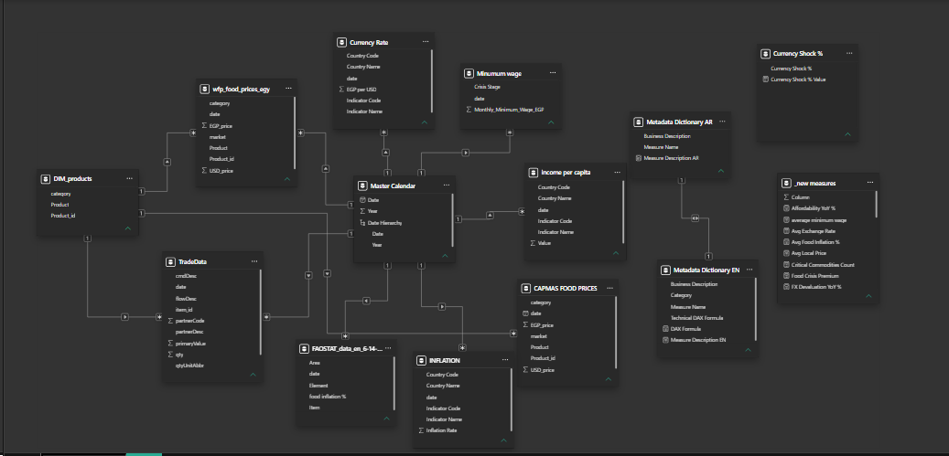

Below is the exhaustive documentation of every DAX measure engineered for this project.
Table 4: The Affordability Nexus Measures
Measure Name | Business Logic / Explanation | DAX Formula
Affordability YoY % | Calculates the year-over-year percentage change in how many units a minimum wage earner can afford. | VAR UnitsPY = CALCULATE([Units Affordable], PREVIOUSYEAR('Master Calendar'[date])) RETURN DIVIDE([Units Affordable] - UnitsPY, UnitsPY, 0)
average minimum wage | Calculates the average baseline minimum wage across the selected timeline. | AVERAGE('Minumum wage'[Monthly_Minimum_Wage_EGP])
Food Crisis Premium | Measures how aggressively food inflation is outpacing the general headline CPI. | [Avg Food Inflation %] - [Headline CPI]
Income Erosion Index | Measures how much of the monthly minimum wage is consumed by a month's worth of food costs. | DIVIDE([Avg Local Price] * 30, AVERAGE('Minumum wage'[Monthly_Minimum_Wage_EGP]), 0)
Physical Units Lost | Tracks the total drop in affordable units from the start of the project timeline to the end. | VAR StartYear = MIN('Master Calendar'[Year]) VAR EndYear = MAX('Master Calendar'[Year]) VAR UnitsStart = CALCULATE([Units Affordable], 'Master Calendar'[Year]=StartYear) VAR UnitsEnd = CALCULATE([Units Affordable], 'Master Calendar'[Year]=EndYear) RETURN UnitsEnd - UnitsStart
Retained Income | Calculates the remaining purchasing power percentage after basic food costs are deducted. | 1 - [Income Erosion Index]
Simulated Price (EGP) | Projects the local price impact using a 0.50 Exchange Rate Pass-Through (ERPT) multiplier. | VAR ERPT = 0.50 VAR CurrencyShock = 'Currency Shock %'[Currency Shock % Value] VAR RealImpact = CurrencyShock * ERPT RETURN [Avg Local Price] * (1 + RealImpact)
Units Affordable | Calculates the absolute number of food units the current monthly income can buy. | Units Affordable =  AVERAGEX(  VALUES('wfp_food_prices_egy'[Product]),  DIVIDE(  AVERAGE('Minumum wage'[Monthly_Minimum_Wage_EGP]),  [Avg Local Price],  0  )  )
Table 5: Core Macro Measures
Measure Name | Business Logic / Explanation | DAX Formula
Avg Exchange Rate | Returns the average Egyptian Pound to US Dollar exchange rate. | AVERAGE('Currency Rate'[EGP per USD])
Avg Food Inflation % | Averages the global FAO food inflation percentages. | AVERAGE('FAOSTAT_data_en_6-14-2026'[food inflation %])
Avg Local Price | Returns the average local market price in Egyptian Pounds. | AVERAGE('wfp_food_prices_egy'[EGP_price])
Headline CPI | Calculates the general consumer price index inflation rate. | AVERAGE('INFLATION'[Inflation Rate])
Monthly Income EGP | Converts the annual GDP per capita value into a monthly metric. | DIVIDE(AVERAGE('income per capita'[Value]), 12, 0)

Table 6: Perspective Analytics Measures
Measure Name | Business Logic / Explanation | DAX Formula
Max Category Spike % | Identifies the absolute highest YoY price jump across all food categories. | MAXX(VALUES('wfp_food_prices_egy'[category]), [Price YoY %])
Most Volatile Category | Dynamically returns the name of the food category experiencing the highest price volatility. | CALCULATE(SELECTEDVALUE('wfp_food_prices_egy'[category]), TOPN(1, ALLSELECTED('wfp_food_prices_egy'[category]), [Price YoY %], DESC))
Risk Status | Categorizes commodity risk levels based on purchasing power drops. | SWITCH(TRUE(), [Affordability YoY %] <= -0.20, "CRITICAL", [Affordability YoY %] < 0, "WARNING", [Affordability YoY %] >= 0, "STABLE", "No Data")
Survival Basket Price Growth % | Averages the YoY price growth for 5 critical survival items (Rice, Sugar, Wheat flour, Vegetable oil, Poultry). | CALCULATE(AVERAGEX(VALUES('wfp_food_prices_egy'[Product]), [Price YoY %]), 'wfp_food_prices_egy'[Product] IN {"Rice","Sugar","Wheat flour","Vegetable oil","Poultry"})
Table 7: Scatter Plot & UI Logic
Measure Name | Business Logic / Explanation | DAX Formula
Quadrant Line X | Calculates the dynamic average Price YoY % to form the center X-axis. | CALCULATE(AVERAGEX(VALUES('DIM_products'[Product]), [Price YoY %]), ALLSELECTED('DIM_products'[Product]))
Quadrant Line Y | Calculates the dynamic average Price Volatility % to form the center Y-axis. | CALCULATE(AVERAGEX(VALUES('DIM_products'[Product]), [Price Volatility %]), ALLSELECTED('DIM_products'[Product]))
Scatter Color Code | Dynamically assigns hex color codes to scatter plot dots based on quadrant position. | VAR CurrentX=[Price YoY %] VAR CurrentY=[Price Volatility %] VAR CenterX=[Quadrant Line X] VAR CenterY=[Quadrant Line Y] RETURN IF(ISBLANK(CurrentX)||ISBLANK(CurrentY), BLANK(), IF(CurrentX>=CenterX && CurrentY>=CenterY, "#D32F2F", IF(CurrentX<CenterX && CurrentY<CenterY, "#2E75B6", "#838383")))
Table 8: Macro Trade Reality Measures
Measure Name | Business Logic / Explanation | DAX Formula
Global Cost Per Ton (USD) | Calculates the actual USD cost per metric ton of imported goods. | DIVIDE([Import Value (USD)], [Import Volume (MT)], 0)
Highest Risk Partner | Identifies the sovereign trade partner supplying the maximum import volume. | CALCULATE(MAX('TradeData'[partnerDesc]), TOPN(1, ALLSELECTED('TradeData'[partnerDesc]), CALCULATE(SUM('TradeData'[qty])), DESC))
Import Value (USD) | Sums the total USD value of international trade imports. | SUMX(TradeData,TradeData[primaryValue])
Import Volume (MT) | Sums the total metric ton quantity of imports. | SUMX(TradeData,TradeData[qty])
Total Import Cost (EGP) | Converts the global USD import value into local currency based on the exchange rate. | [Import Value (USD)] * [Avg Exchange Rate]
Table 9: Time Intelligence Measures
Measure Name | Business Logic / Explanation | DAX Formula
Critical Commodities Count | Counts the distinct number of products that have hit a >20% loss in affordability. | COUNTROWS(FILTER(VALUES('wfp_food_prices_egy'[Product]), [Affordability YoY %] <= -0.20))
FX Devaluation YoY % | Calculates the year-over-year percentage collapse of the Egyptian Pound against the USD. | VAR RatePY = CALCULATE([Avg Exchange Rate], PREVIOUSYEAR('Master Calendar'[date])) RETURN DIVIDE([Avg Exchange Rate] - RatePY, RatePY, 0)
Max FX Devaluation | Finds the absolute maximum YoY devaluation rate across the timeline. | MAXX(ALL('Master Calendar'[Year]), [FX Devaluation YoY %])
Price PY | Calculates the average local price of commodities in the previous year. | CALCULATE([Avg Local Price], PREVIOUSYEAR('Master Calendar'[Date]))
Price Volatility % | Calculates the relative standard deviation to measure price volatility. | VAR StandardDeviation = STDEVX.P(VALUES('Master Calendar'[Year]), [Avg Local Price]) VAR AveragePrice=[Avg Local Price] RETURN DIVIDE(StandardDeviation, AveragePrice, 0)
Price YoY % | Calculates the year-over-year percentage growth of local commodity prices. | DIVIDE([Avg Local Price] - [Price PY], [Price PY], 0)
Selected End Year | Returns the maximum year currently selected in the calendar. | MAX('Master Calendar'[Year])
Selected Start Year | Returns the minimum year currently selected in the calendar. | MIN('Master Calendar'[Year])

2.2 UI/UX Design & Prototyping
The report architecture was engineered to signal economic urgency through high-impact visual cues. A rigorous UI/UX methodology was implemented to maintain analytical precision and scalability across the four-page interface. To eliminate subjective interpretation, the design utilizes automated conditional formatting governed by backend DAX calculations.

Interface Standards & Automated Color Logic
To achieve optimal clarity, the system leverages a dynamic color engine integrated into the DAX layer (primarily via the Scatter Color Code measure). Visual markers automatically re-categorize based on a commodity's statistical position within the price-volatility matrix:
- 🔴 Hyper-Volatile (Crimson – #D32F2F): Assigned to commodities in the top-right quadrant exhibiting extreme price spikes and high market instability.
- 🟢 Stable Baseline (Teal – #2E75B6): Assigned to items in the lower-left quadrant with manageable inflation and low variance.
- ⚠️ Moderate Risk (Gray – #838383): Assigned to intermediary quadrants to highlight emerging economic concerns.

2.3 Dashboard Navigation Guide
The Power BI environment is organized into four analytical tiers, guiding the user from national macroeconomic trends down to household-level affordability and global trade dependencies.

Page 1: The Macro Shock Catalyst
The primary landing page acts as the analytical anchor for the entire project, monitoring sovereign-level shocks and the mechanics of currency devaluation. It proves that the root cause of the crisis is monetary, not agricultural.
Core KPIs & The "Food Crisis Premium"
- Max FX Devaluation: Quantifies the volatile economic climate, tracking the peak currency collapse of 59.84% in 2023. The average exchange rate violently deteriorated from 15.75 EGP/USD in 2020 to 45.29 EGP/USD in 2024.
- The Food Crisis Premium: This reveals a devastating gap between general and food-specific inflation. While headline CPI reached a high of 33.88% in 2023, average food inflation surged to nearly double that rate at 63.57%. This 29.69 percentage-point gap proves that food costs acted as the primary anchor dragging down the Egyptian economy.
Visualizations & Transmission Mechanics
- Clustered Column & Line Chart (Inflation vs. Currency Shock): Compares CPI directly against average exchange rates. This visual demonstrates a near 1:1 correlation between exchange rate spikes and headline CPI growth, proving that local inflation was fundamentally imported.
- Waterfall Chart (YoY Devaluation): Decomposes yearly foreign exchange movements to illustrate the compounding nature of the crisis: a 22.47% devaluation drop in 2022, immediately followed by the catastrophic 59.84% crash in 2023, and continuing with a 47.91% rate in 2024.
- Trend Line (Food vs. General Economy): A dedicated trend line contrasting food-specific inflation against the general CPI, explicitly visualizing the "Food Crisis Premium" and the severe strain on purchasing power.
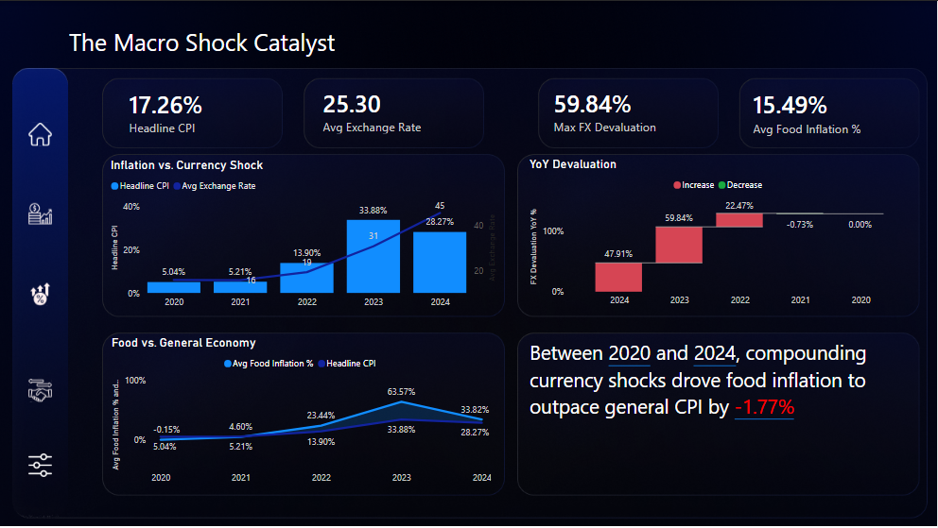

Page 2: Architecture: Sectoral Transmission (Food vs. Economy)
This segment drills down into specific food commodities to identify the primary drivers of market instability and isolate which items destroyed household budgets.
Core KPIs & The Risk Ledger
- Survival Basket Price Growth: Monitors a custom index of five critical survival items (Rice, Sugar, Wheat flour, Vegetable oil, Poultry). This basket saw massive inflationary growth, peaking at 86.29% in 2023.
- Critical Commodities Count: Tracks the expansion of high-risk items (defined as having a >20% loss in affordability). This metric shows a systemic failure, jumping from just 1 critical item in 2022 to 11 critical items within a single year (2023).
- Max Category Spike & Volatility Shift: Highlights extreme isolated shocks, such as Sugar reaching an unprecedented 96.60% YoY price spike in 2023. It also reveals that the "Most Volatile Category" shifted from Vegetables and fruits (2022) to Miscellaneous food (2023/2024).
Visualizations & DAX-Driven UI
- Risk Ledger Matrix: Tracks detailed price growth and DAX-assigned status labels. Items like Farm Chicken (94.03% spike) and Eggs (87.85% spike) dynamically trigger a "CRITICAL (Severe Purchasing Power Loss)" status, while domestic stabilizers like Fava Beans and Potatoes maintained a "STABLE" or "WARNING" status in earlier years.
- Quadrant-Based Scatter Plot: Maps Price YoY % against Price Volatility using dynamic, DAX-driven conditional formatting. Items in the hyper-toxic top-right quadrant flash Crimson Red, stable items in the bottom-left appear in Teal, and intermediary quadrants display as Warning Gray.

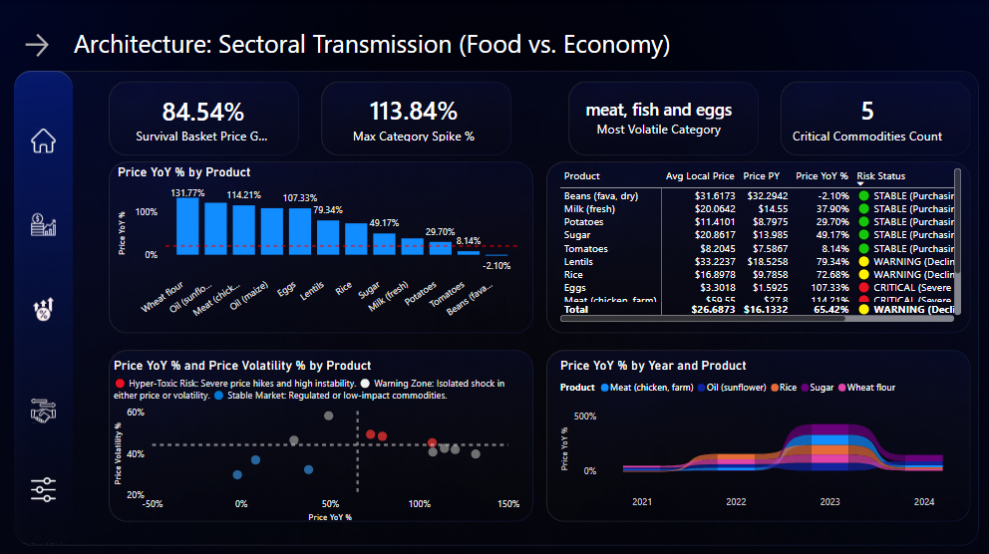

Page 3: Household Reality (Wages vs. Real Erosion)
This tier connects macroeconomic data to the tangible financial realities of the Egyptian labor force, empirically proving the "Illusion of Wealth". It demonstrates that raising nominal wages without curbing imported, foreign-exchange-driven inflation creates a fiscal trap where citizens work harder but afford significantly less.

Core KPIs & The "Illusion of Wealth"
- Wages vs. Physical Capacity: Compares nominal minimum wage increases against real purchasing power metrics. Despite the government aggressively tripling the minimum wage from 2,000 EGP in 2020 to 6,000 EGP in 2024, the "Units Affordable" capacity dropped from 303 units in 2021 to just 258 units in 2024.
- Average Income Erosion: Tracks the average percentage of income consumed by food. The baseline in 2021 was 20.5%, which collapsed to an average erosion of 34.2% in 2023. Even with the 2024 wage hike to 6,000 EGP, average erosion still sits at a dangerous 22.5%.
- The 2023 Affordability Crash: Identifies 2023 as the worst year for purchasing power, where average affordability collapsed by a staggering -34.6% across all commodities.
Commodity-Specific Insights (The Budget Destroyers) The dashboard drills down into how specific essential items destroyed household budgets, particularly during the 2023 macroeconomic shock:
- Farm Chicken: Reached an unprecedented Income Erosion Index peak of 76.08% in 2023, leaving a minimum-wage citizen with only 23.92% of their income for all other living expenses. Overall affordability for poultry dropped -43% in 2023 alone.
- Cooking Oils (Maize & Sunflower): In 2023, a month's supply of Maize Oil consumed 69.93% of the minimum wage, while Sunflower Oil consumed 61.37%. Shockingly, despite the 2024 wage hikes, Sunflower Oil now eats up 6.01% more of a citizen's salary (41.31%) than it did in 2020 (35.30%).
- Wheat Flour: Consumed 19.79% of a minimum wage earner's monthly income in 2024, leaving an 80.21% retained margin. By 2024, citizens could afford -12.6% fewer units of wheat flour than they could in 2020.
- Other Critical Staples: In 2023, purchasing power violently contracted for Sugar (-43%), Eggs (-41%), Rice (-40%), and Lentils (-38%).
- Domestic Stabilizers: The data proves a stark contrast between imported goods and pure domestic crops. Locally sourced items like Tomatoes, Potatoes, and Fresh Fava Beans actually stabilized the market, seeing slight increases in affordability because their localized inflation was outpaced by wage hikes.

Visualizations & Interactive Features
- 100% Stacked Bar Chart (Income Erosion vs. Retained Income): Visually highlights the severe human cost of inflation by displaying the exact percentage of income consumed by a selected food item versus the retained income left for housing, healthcare, and education.
- Waterfall Chart (Affordability YoY %): Tracks the sharp annual decline in real-world physical affordability, clearly illustrating the compounding collapse: a -22% drop in 2022, followed by a massive -31% drop in 2023.
- Combo Line and Clustered Column Chart (Wage vs. Units Affordable): A critical visual proving the wage-inflation disconnect. It shows the nominal wage bars climbing upward over time, while the line representing real physical units affordable violently trends downward.
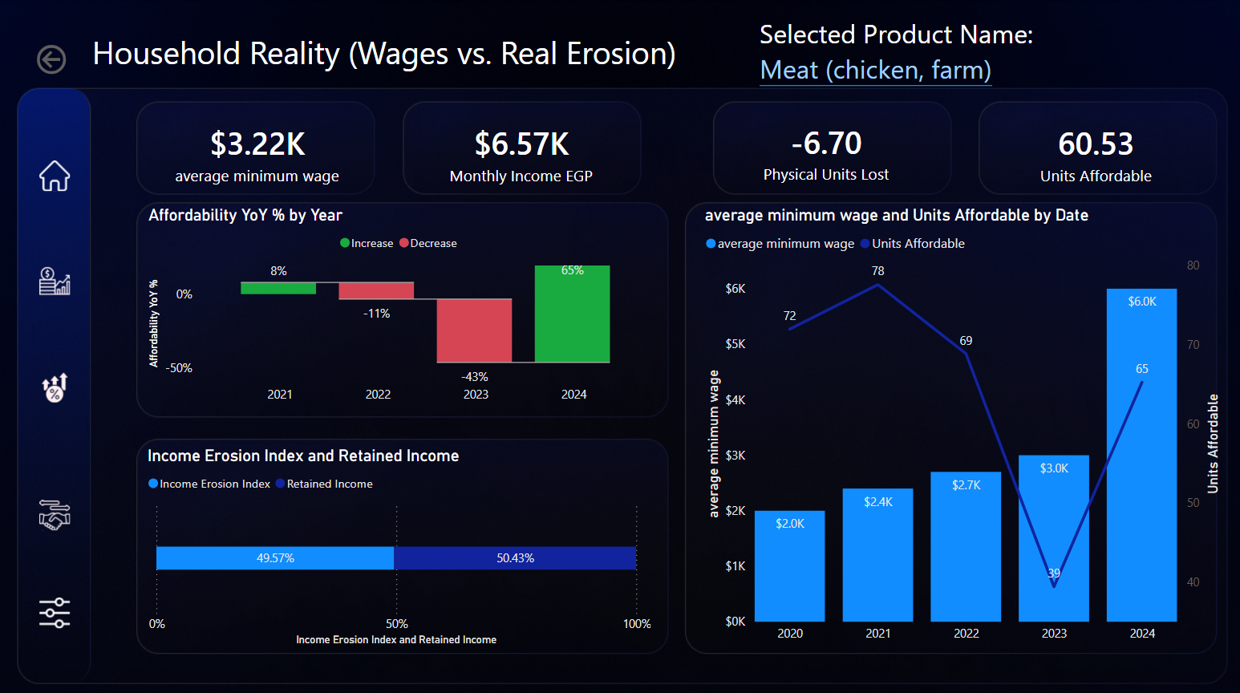

Page 4: Sovereign Trade Vulnerabilities
The final analytical layer examines the macroeconomic paradox of the crisis by mapping supply chain vulnerabilities, foreign trade dependencies, and predictive pricing.
Core KPIs & The Import Paradox
- Stable Global USD vs. Exploding EGP Costs: Benchmarks the root paradox of the crisis. The data proves global commodity prices actually dropped from 0.98/ton (2024). However, due to the currency collapse, the total local import bill exploded from 16.2 Billion EGP to an unsustainable 119.2 Billion EGP (a +635% spike).
- Highest Risk Partner: Identifies the extreme sovereign concentration risk. Brazil dominated the supply chain, supplying a massive 2.25 Billion MT of Egypt's agricultural import volume.
Visualizations & Predictive Modeling
- Azure Geospatial Maps: Visually plots trade volumes across the globe, exposing the severe supply chain centralization on key partners like Brazil, Australia (1.41 Billion MT), and the Russian Federation (1.38 Billion MT).
- Clustered Bar Charts (Value Exposures): Identifies the highest-value USD drain on the economy, specifically flagging Sunflower Oil (1.87 Billion), and Dry Fava Beans ($1.48 Billion) as the primary strategic targets for sovereign hedging.
- Predictive Analytics (ERPT Simulation Line Chart): A highly advanced "What-If" parameter utilizing a 0.50 Exchange Rate Pass-Through (ERPT) multiplier. It visually proves that average local prices perfectly mirrored the currency shock (rising from 16.13 EGP to 45.14 EGP) and enables policymakers to preemptively simulate local market food prices up to 6 months in advance based on forecasted Central Bank currency adjustments.
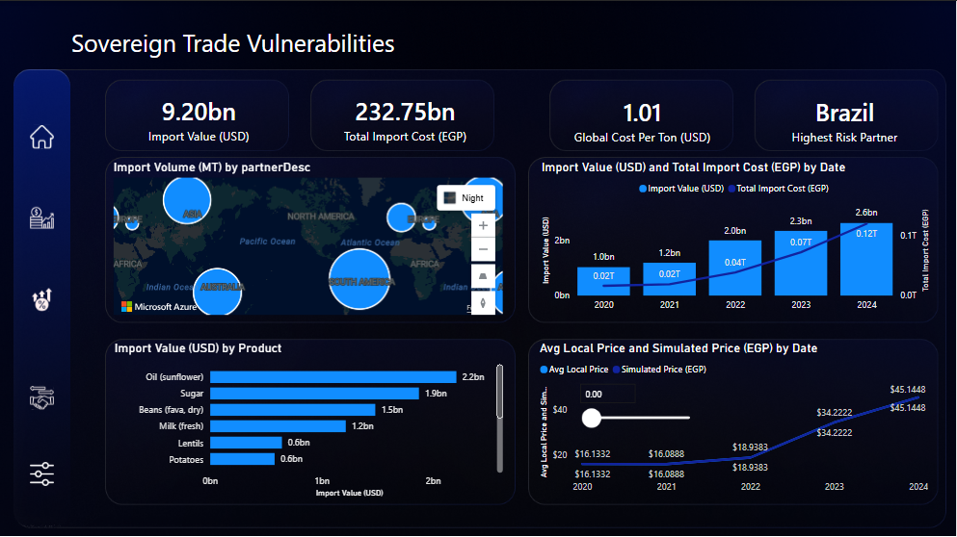

Chapter 3: Analysis & Insights
This chapter synthesizes the granular data compiled between 2020 and 2024 to diagnose the structural failures in Egypt's food security framework. By isolating the correlation between currency volatility and market price transmission, we can move from observation to actionable strategic intervention.

3.1 Page 1: The Macro Shock Catalyst

A. Core KPIs (Headline CPI, Avg Exchange Rate, Max FX Devaluation, Avg Food Inflation)
📌 Core KPI Snapshot — Page 1
📈 | Max FX Devaluation | 59.84%
💱 | Avg Exchange Rate (2020→2024) | 15.75 → 45.29 EGP/USD
⚠️ | Headline CPI (2023 peak) | 33.88%
🔴 | Avg Food Inflation (peak) | 63.57%
🔎 Insight: The macroeconomic data reveals a massive financial shock centered in 2023. The Max FX Devaluation hit 59.84%, driving the Average Exchange Rate from 15.75 EGP/USD in 2020 to a peak of 45.29 EGP/USD in 2024. This currency collapse forced Headline CPI up to 33.88% in 2023, but more dangerously, Average Food Inflation violently outpaced general inflation, hitting 63.57%.
✅ Recommended Action: The Ministry of Finance must separate Food Inflation targeting from general CPI targeting. Standard monetary policy (like raising interest rates) will not fix food inflation driven by currency devaluation.

B. Visual 1 & 2 (Line/Clustered Chart for CPI vs FX & Waterfall Chart for Devaluation)
🔎 Insight: The waterfall chart proves the currency crisis was compounding, with a 22.47% devaluation in 2022 followed by the 59.84% crash in 2023. The clustered chart shows a near 1:1 correlation between the exchange rate spikes and headline CPI growth.
✅ Recommended Action: Implement automated financial triggers that temporarily suspend import tariffs on essential food goods whenever the FX Devaluation YoY% crosses a 15% threshold.

C. Visual 3 (Line Chart: Food Inflation vs. Headline CPI)
🔎 Insight: The visual explicitly proves the "Food Crisis Premium." In 2023, Food Inflation (63.57%) was nearly double the Headline CPI (33.88%). Food costs are acting as the primary anchor dragging down the Egyptian economy.
✅ Recommended Action: Subsidies must be dynamically linked to the "Food Crisis Premium" rather than general inflation metrics to ensure social safety nets retain actual purchasing power.

3.2 Page 2: Architecture: Sectorial Transmission (Food vs. Economy)

A. Core KPIs (Survival Basket Growth, Max Category Spike, Volatile Category, Critical Commodities)
📌 Core KPI Snapshot — Page 2
📈 | Survival Basket Price Growth (2023) | 86.29%
🌀 | Most Volatile Category | Miscellaneous Food
🔴 | Critical Commodities Count (2022→2023) | 1 → 11
⚠️ | Max Category Spike (Sugar, 2023) | 96.60%
🔎 Insight: The Survival Basket Price Growth hit a devastating 86.29% in 2023. The Most Volatile Category shifted from "vegetables and fruits" in 2022 to "miscellaneous food" in 2023/2024. This systemic shock resulted in the "Critical Commodities Count" jumping from just 1 item in 2022 to 11 items in 2023.
✅ Recommended Action: The government must expand emergency rationing beyond traditional grains to include the newly identified volatile "miscellaneous food" categories to protect basic caloric intake.

B. Visual 1, 2 & 4 (YoY Bar Chart, Risk Matrix & Ribbon Chart)
🔎 Insight: The visuals identify the exact products failing the market during the "Great Affordability Crash" of 2023, where average affordability collapsed by a staggering -34.6% across all commodities. The Risk Matrix must flash "CRITICAL" for the top 5 budget-destroying commodities that wiped out purchasing power: Sugar (-43%), Farm Chicken (-43%), Eggs (-41%), Rice (-40%), and Lentils (-38%). Furthermore, the data reveals a stark contrast between imported shocks and domestic resilience. Import-dependent items like Sunflower Oil and Wheat Flour saw net purchasing power losses of -14.5% and -12.6% respectively between 2020 and 2024, whereas pure domestic crops like Tomatoes and Potatoes stabilized the market.
✅ Recommended Action: Initiate immediate, heavy domestic production subsidies specifically targeting the poultry supply chain (Farm Chicken and Eggs) and domestic Sugar refining to artificially force local market prices down.

C. Visual 3 (Scatter Chart: Price YoY vs. Volatility)
🔎 Insight: The scatter logic identifies that items like Lentils (79.76% spike) and Sunflower Oil (71.33% spike) are sitting in high-risk, high-volatility quadrants.
✅ Recommended Action: Utilize this scatter model as an early-warning system. Any commodity crossing into the "Hyper-Toxic" top-right quadrant should trigger an automatic emergency import tender by the Ministry of Supply.

3.3 Page 3: Household Reality (Wages vs. Real Erosion)

A. Core KPIs (Avg Minimum Wage, Monthly Income, Physical Units Lost, Units Affordable)
📌 Core KPI Snapshot — Page 3
📈 | Avg Minimum Wage (2020→2024) | 2,000 → 6,000 EGP
💰 | Nominal Monthly Income (2024) | 9,941 EGP
📉 | Units Affordable (2021→2024) | 303 → 258
🔴 | Risk Status | CRITICAL
🔎 Insight: The data proves the "Illusion of Wealth." Despite the government aggressively tripling the minimum wage from 2,000 EGP in 2020 to 6,000 EGP in 2024, real purchasing power crashed. In 2021 (wage 2,400 EGP), a citizen could buy an average of 303 units of food. In 2024 (wage 6,000 EGP), they can only afford 258 units. The Income Erosion Index reveals an even darker reality: in 2023, the cost of Farm Chicken alone consumed an unbelievable 76% of a minimum wage earner's monthly income, leaving them with just 24% for housing, utilities, and education. Furthermore, a basic staple like Sunflower Oil eats up 6.01% MORE of a citizen's salary today (41.31%) than it did in 2020 (35.3%). The citizen is working harder for 6,000 EGP, only to surrender a larger percentage of it to buy the exact same food.
✅ Recommended Action: Introduce a "Food Inflation Rebate" program directly crediting the bank accounts of minimum-wage citizens whenever the Income Erosion Index exceeds 15%.

B. Visual 1 & 2 (Waterfall Affordability Drop & Wage vs. Units Chart)
🔎 Insight: The Affordability Waterfall visually represents the collapse, showing a 22% drop in 2022 and a 31% drop in 2023. The Wage vs. Units clustered chart shows that while the wage bar goes up, the units line violently trends down, proving nominal wage hikes are failing.
✅ Recommended Action: Freeze utility and non-food government taxation for minimum wage earners during years where the Affordability YoY% drops below -10%.

C. Visual 3 (100% Stacked Bar: Income Erosion vs. Retained Income)
🔎 Insight: This visual highlights the true human cost. The Income Erosion Index reveals an unprecedented shock: in 2023, the cost of Farm Chicken alone consumed an unbelievable 76.08% of a minimum wage earner's monthly income. This means over three-quarters of a citizen's salary was eaten up by a single survival food item, leaving just 23.92% for housing, healthcare, utilities, and education.
✅ Recommended Action: Introduce a "Food Inflation Rebate" program directly crediting the bank accounts of minimum-wage citizens whenever the individual product Income Erosion Index exceeds 15%.

3.4 Page 4: Sovereign Trade Vulnerabilities

A. Core KPIs (Import Value USD, Total Import EGP, Global Cost/Ton, Highest Risk Partner)
📌 Core KPI Snapshot — Page 4
🟢 | Global Cost/Ton (2020→2024) | $1.05 → $0.98
🔴 | Total Import Cost (2020→2024) | 16.2B → 119.2B EGP
🌍 | Highest Risk Partner (2022–2024) | Brazil
⚠️ | Sovereign Concentration Risk | HIGH
🔎 Insight: Global Cost Per Ton actually dropped from $1.05 in 2020 to $0.98 in 2024. However, the Total Import Cost exploded from 16.2 Billion EGP to 119.2 Billion EGP. This proves Egypt is importing a currency crisis, not a food shortage. Furthermore, the Highest Risk Partner shifted entirely to Brazil from 2022 to 2024.
✅ Recommended Action: Aggressively pursue "Local Currency Settlement" trade agreements with Brazil to bypass the US Dollar, entirely nullifying the EGP-to-USD conversion penalty.

B. Visual 1 (Azure Maps: Import Volume Geographic Plot)
🔎 Insight: The map highlights extreme supply chain centralization. Brazil (2.25 Billion MT), Australia (1.41 Billion MT), and the Russian Federation (1.38 Billion MT) control the vast majority of Egypt's food lifeline.
✅ Recommended Action: Diversify sovereign risk by mandating that no single country can account for more than 25% of Egypt's total agricultural import volume.

C. Visual 2 & 3 (Total Cost EGP vs USD Value & Top Products Bar Chart)
🔎 Insight: The clustered bar chart reveals Egypt's most expensive exposures: Sunflower Oil ($2.2 Billion), Sugar ($1.87 Billion), and Dry Fava Beans ($1.48 Billion).
✅ Recommended Action: Implement a Sovereign Hedging program specifically for Sunflower Oil and Sugar to lock in global prices and insulate the domestic market from further EGP collapses.

D. Visual 4 (Line Chart: Avg Local Price vs. Simulated Price)
🔎 Insight: The simulation visual proves that local prices (rising from 16.13 EGP in 2020 to 45.14 EGP in 2024) perfectly mirror Exchange Rate Pass-Through (ERPT) shocks.
✅ Recommended Action: Utilize this simulation model to predict local market prices 6 months in advance based on forecasted currency shifts, allowing preemptive rather than reactive policy-making.

Glossary & Terminology
To ensure clarity for all stakeholders reading this report, the following technical and economic terms used throughout the dashboard and analysis are defined below:
DAX (Data Analysis Expressions): The formula language used in Microsoft Power BI to create custom calculations, measures, and data aggregations (such as calculating the Income Erosion Index).
Exchange Rate Pass-Through (ERPT): An economic metric that measures how much a change in the exchange rate (currency devaluation) affects local domestic prices.
FX Devaluation (Foreign Exchange Devaluation): The intentional or market-driven drop in the value of a country's currency (the Egyptian Pound) relative to a foreign reference currency (the US Dollar).
Headline CPI (Consumer Price Index): The standard measure of general inflation. It tracks the average change over time in the prices paid by urban consumers for a general basket of consumer goods and services.
Income Erosion Index: A custom KPI developed for this project that measures the exact percentage of a citizen's monthly minimum wage that is consumed entirely by basic food costs.
Power Query (M Language): The data transformation and preparation engine used to clean, filter, and reshape the raw data before it is loaded into the Power BI model.
Star Schema: A database modeling structure where a central "Fact Table" (containing measurable, quantitative data like prices or import volumes) is connected to multiple "Dimension Tables" (containing descriptive data like dates, product names, or operators).
Survival Basket: A specific, filtered group of the most critical, high-calorie commodities required for basic human sustenance in Egypt (specifically tracking Rice, Sugar, Wheat Flour, Vegetable Oil, and Poultry).
Units Affordable: A custom KPI representing the physical purchasing power of a citizen. It calculates exactly how many units of average food a monthly minimum wage can buy at any given time.

Conclusion
The analysis conducted between 2020 and 2024 unequivocally demonstrates that Egypt's food security crisis is fundamentally driven by severe currency devaluation and imported inflation, rather than global commodity scarcity. While the global cost per ton of imported goods remained highly stable — even dropping to $0.98 by 2024 — the massive 59.84% collapse in the exchange rate acted as a severe force multiplier, driving total import costs to an unprecedented 119.2 Billion EGP. This macroeconomic shock translated directly into a devastating 63.57% food inflation rate in 2023, aggressively outpacing general inflation and rapidly eroding citizen purchasing power.
Despite nominal minimum wage increases reaching 6,000 EGP, real purchasing capacity collapsed, with the average physical "Units Affordable" metric plummeting from 303 units in 2021 down to a crisis-level of 258 units in 2024. The existing economic safety net has largely failed to keep pace with the hyper-volatility of critical survival items like Sugar, Farm Chicken, and Edible Oils. This dynamic led to severe microeconomic shocks, such as the cost of Farm Chicken alone consuming an unbelievable 76.08% of a minimum wage earner's monthly income in 2023, leaving citizens with a fraction of their salary for other survival needs.
To decouple domestic food security from international foreign exchange shocks, Egypt must pivot from reactive observations to proactive, data-driven interventions. By implementing sovereign hedging on top-value imports like Sunflower Oil and Sugar, actively pursuing Local Currency Settlements to dilute heavy sovereign risk with partners like Brazil, and realigning subsidies to target the newly volatile "miscellaneous food" categories, policymakers can construct a resilient economic shield. Ultimately, stabilizing the market requires legally indexing wages and social safety nets to the "Units Affordable" metric and recognizing food inflation as an independent threat, ensuring long-term systemic stability and protected caloric accessibility for the Egyptian population. The data proves that raising nominal wages without curbing imported inflation creates nothing more than a fiscal illusion. You cannot solve a foreign-exchange-driven food crisis with local currency wage hikes.

